**Numerical Optimisation codes**

**Anshika Singh**

**16010**

**Code 1**

import sympy as sp

x1,x2= sp.symbols('x1 x2')

function= input("Enter the function")

gradient= [sp.diff(function,x1), sp.diff(function,x2)]

hassien = [[sp.diff(gradient [0],x1), sp.diff(gradient [0],x2)],[sp.diff(gradient [0],x1), sp.diff(gradient [0],x2)]]

print("Gradient:")

print(gradient)

print ("\nHassien:")

print (hassien)

**Output:**

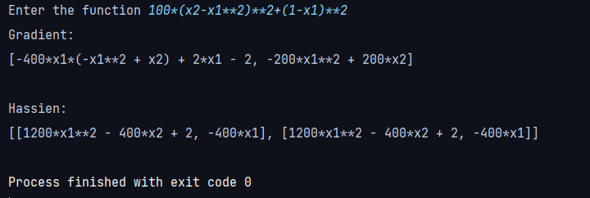

**Code 2**

import numpy as np

def objective_function(x):

return x**2 + 4*x + 4

def gradient(x):

return 2*x + 4

def line_search(initial_x, learning_rate, epsilon):

x = initial_x

iteration = 0

while True:

gradient_x = gradient(x)

new_x = x - learning_rate * gradient_x

# Check for convergence

if abs(new_x - x) < epsilon:

break

x = new_x

iteration += 1

return x, objective_function(x), iteration

# Initial parameters

initial_x = 0.0

learning_rate = 0.1

epsilon = 1e-6

result_x, result_min, iterations = line_search(initial_x, learning_rate, epsilon)

print(f"Minimum value found at x = {result_x}")

print(f"Minimum objective function value = {result_min}")

print(f"Iterations: {iterations}")

**Output:**

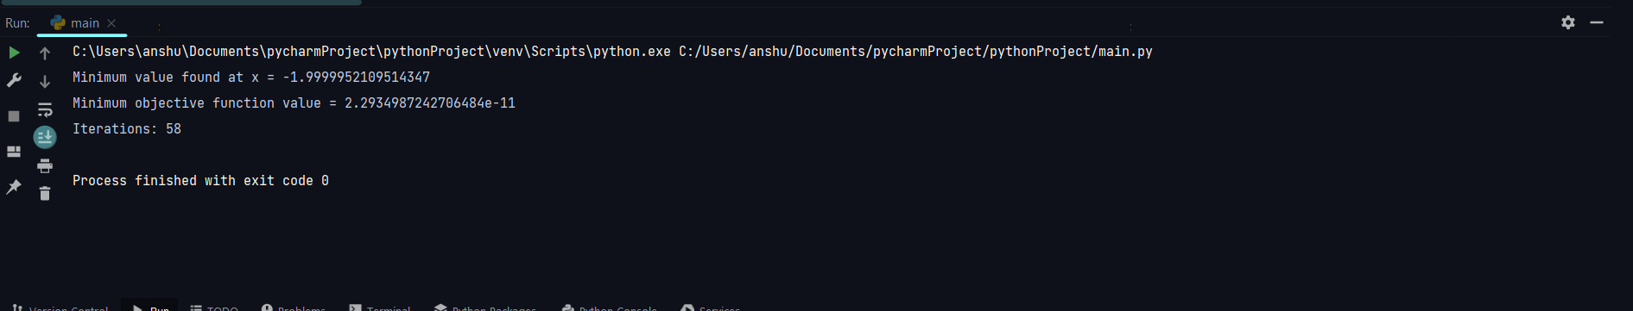

**Code 3:**

import matplotlib.pyplot as plt

# Define the constraints

# Coefficients of the form: Ax + By <= C

constraints = [

(2, 1, 20),

(4, -5, 10)

]

# Define the objective function coefficients

# Z = cx + dy

c = 3

d = 4

# Create a function to plot the constraints

def plot_constraints():

plt.figure()

for constraint in constraints:

A, B, C = constraint

x = [0, C / A] # considering x = 0 and x = C/A to plot lines

y = [(C - A * xi) / B for xi in x]

plt.plot(x, y, label=f"{A}x + {B}y <= {C}")

plt.xlabel('x')

plt.ylabel('y')

plt.axhline(0, color='black',linewidth=0.5)

plt.axvline(0, color='black',linewidth=0.5)

plt.legend()

plt.show()

# Function to calculate Z value

def calculate_Z(x, y):

return c * x + d * y

# Finding corner points and calculating Z values

def find_optimal_solution():

corner_points = []

for constraint in constraints:

A, B, C = constraint

x = 0 if A == 0 else C / A

y = 0 if B == 0 else C / B

corner_points.append((x, y))

max_Z = float('-inf')

optimal_point = None

for point in corner_points:

x, y = point

current_Z = calculate_Z(x, y)

if current_Z > max_Z:

max_Z = current_Z

optimal_point = point

return optimal_point, max_Z

# Plot the constraints

plot_constraints()

# Calculate the optimal solution

optimal_solution, max_Z_value = find_optimal_solution()

# Display the optimal solution

print(f"The optimal solution is at point: {optimal_solution} with Z value: {max_Z_value}")

**Output:**

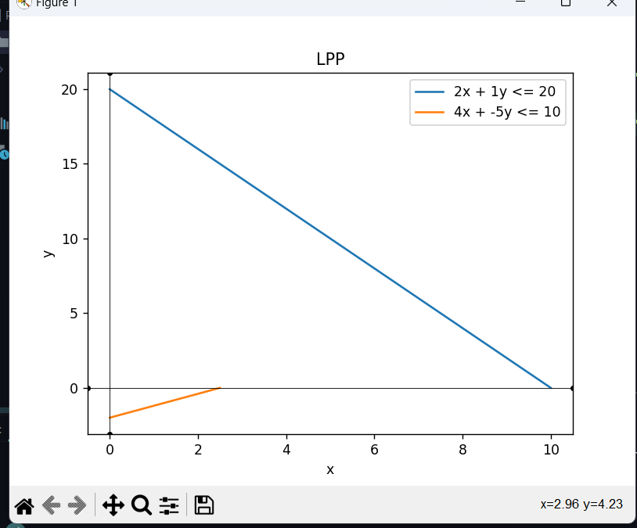

**Code 4**

import numpy as np

import matplotlib.pyplot as plt

# Define the function f(x)

def objective_function(x):

return -10 * np.cos(np.pi * x - 2.2) + (x + 1.5) * x

# Generate x values

x = np.linspace(-5, 5, 20)

print(x)

y = objective_function(x)

print(y)

plt.plot(x, y, label='f(x) = -10Cos(pi x - 2.2) + (x + 1.5) * x')

plt.xlabel('x')

plt.ylabel('f(x)')

plt.title(' Function f(x)')

plt.grid(True)

min_y = min(y)

min_x = x[np.argmin(y)]

plt.scatter(min_x, min_y, color='blue', label=f'Minimum: ({min_x}, {min_y})')

plt.legend()

plt.show()

print("Global optimal solution is", min_x)

print("Optimal function value is”, min_y)

**Output:**

**Code 5:**

import numpy as np

from scipy.optimize import differential_evolution

def objective_function(x):

return -10 * np.cos(np.pi * x - 2.2) + (x + 1.5) * x

bounds = [(-10, 10)]

result = differential_evolution(objective_function, bounds)

min_x = result.x

global_min_val = result.fun

print("global min x: ",min_x)

print("Global Optimal Solution:")

print(f"x = {min_x[0]}")

print(f"f(x) = {global_min_val}")

**Output:**

**Code 6:**

from sympy import symbols, diff, solve, Matrix

x, y, l = symbols('x y lambda')

f = x**2 + y**2

g = x + y - 1

# Define the Lagrangian

L = f - l * g

# Compute partial derivatives

partials = [diff(L, var) for var in (x, y, l)]

# Solve the system of equations

solution = solve(partials, (x, y, l), dict=True)[0]

# Extract the optimal values

optimal_x = solution[x]

optimal_y = solution[y]

# Compute the Hessian matrix

# Compute the Hessian matrix using a list of lists

hessian_list = []

# Iterate over var2

for var2 in (x, y, l):

# Initialize a row for var2

row = []

# Iterate over var1

for var1 in (x, y, l):

# Calculate the second-order partial derivative and append to the row

row.append(diff(L.diff(var1), var2))

# Append the row to the Hessian list

hessian_list.append(row)

# Create an instance of the Matrix class from the list of lists

hessian_matrix = Matrix(hessian_list)

# Display the Hessian matrix

print(hessian_matrix)

hessian_determinant = hessian_matrix.det()

if hessian_determinant > 0:

print("Stationary point is a local minimum.")

elif hessian_determinant < 0:

print("Stationary point is a local maximum.")

else:6

print("Second-order test inconclusive (saddle point or test fails).")

# Display the result

print("Optimal solution:")

print(f"x: {optimal_x}")

print(f"y: {optimal_y}")

**Output:**